**EXPERIMENT-5**

**Submitted by:**Ajay Kumar Tyagi  
500067403  
R171218008  
CSE-DevOps 2018-2022

**Aim:** To create an image and configure it as a webserver using Dockerfile.

**Procedure:**

**1)** In docker to create our own image we can write **Dockerfile**.

**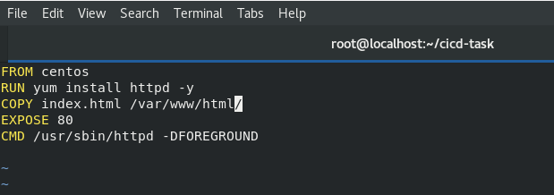  
FROM** keyword is used to tell base image. **RUN** keyword will execute the command while creating image. **CMD** keyword will execute command while launching container. **COPY** keyword will copy the specified file inside the image. **EXPOSE** keyword will expose the container.

**2)** To run the Dockerfile, use command Dockerfile build -t <username/imagename> <Dockerfile-location>.

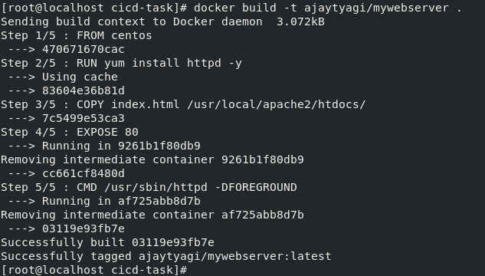

**3)** To push your image to docker hub, you first need to login. For this use command **docker login**. After login use command **docker info** to check if you have logged in successfully.

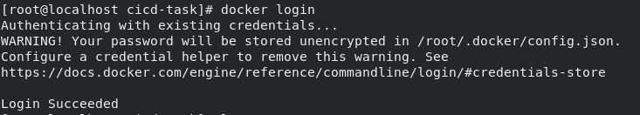  
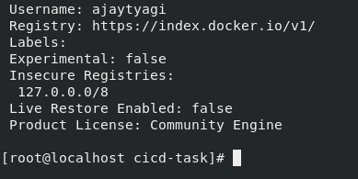

**4)** After creating Dockerfile successfully, we can push our image to Docker hub. Use command **docker push** command for this. Note that image name must containe username followed by image name to push to docker hub.

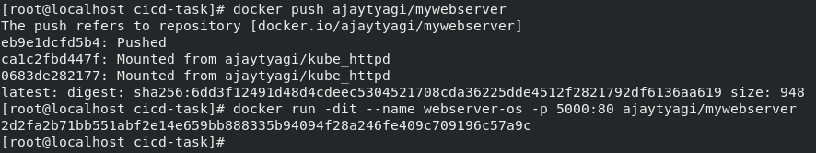  
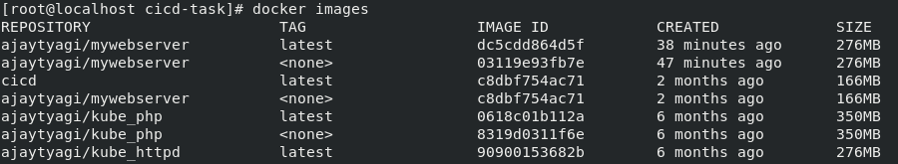

**5)** Go to Docker hub and log in with your username. After log in you should see all images you have pushed.  
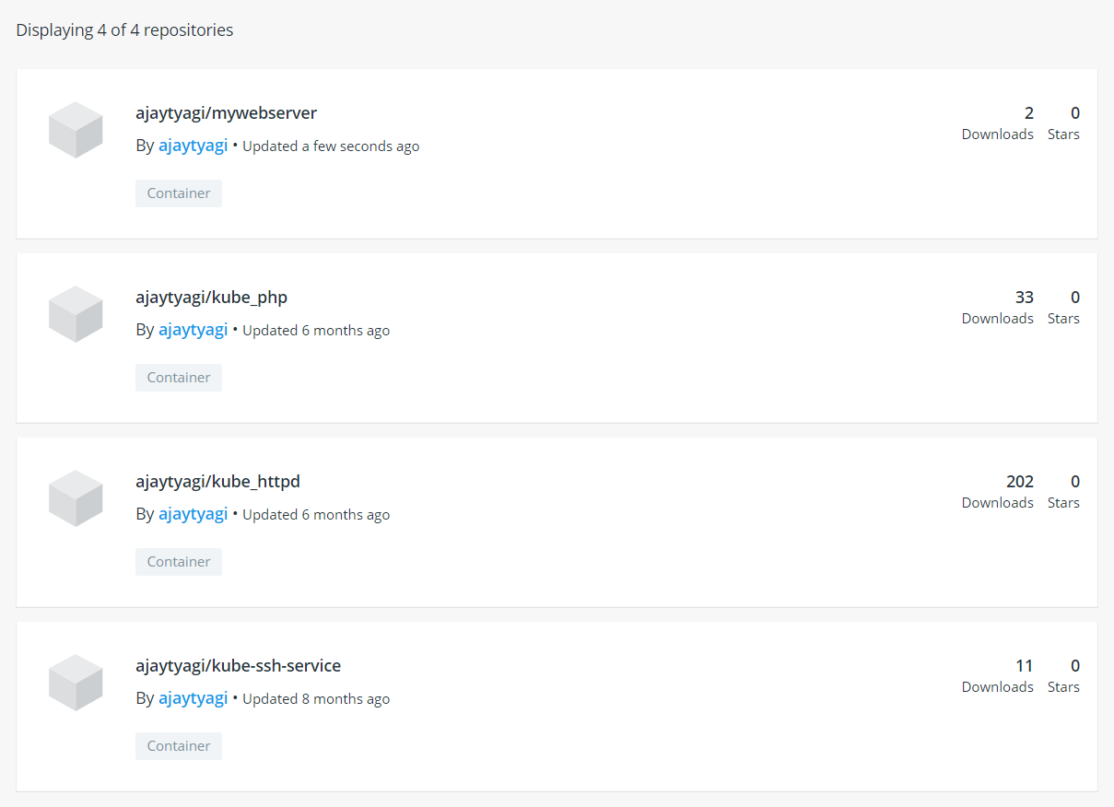

**6)**  Now using the image we have just created, launch a container using command:   
**docker run -dit --name <os-name> -p 5000:80 <image-name>.**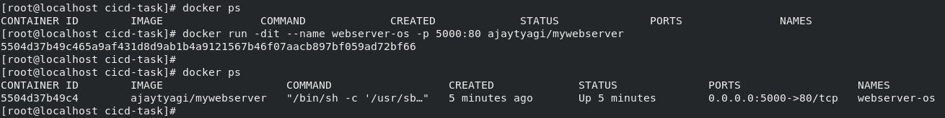

**7)** Lastly on the browser use the IP address of your base OS and use port 5000.  
